Team Suits 2023
Virginia Swim Shop
12207 Gayton Road Richmond, VA 23238
T: 804-754-3402
Goochland team page for orders
https://virginia-swim-shop.shoplightspeed.com/ymca/goochland-ymca/
General Webite:
https://www.virginiaswimshop.com/
For information on the new team suit, use the QR Code
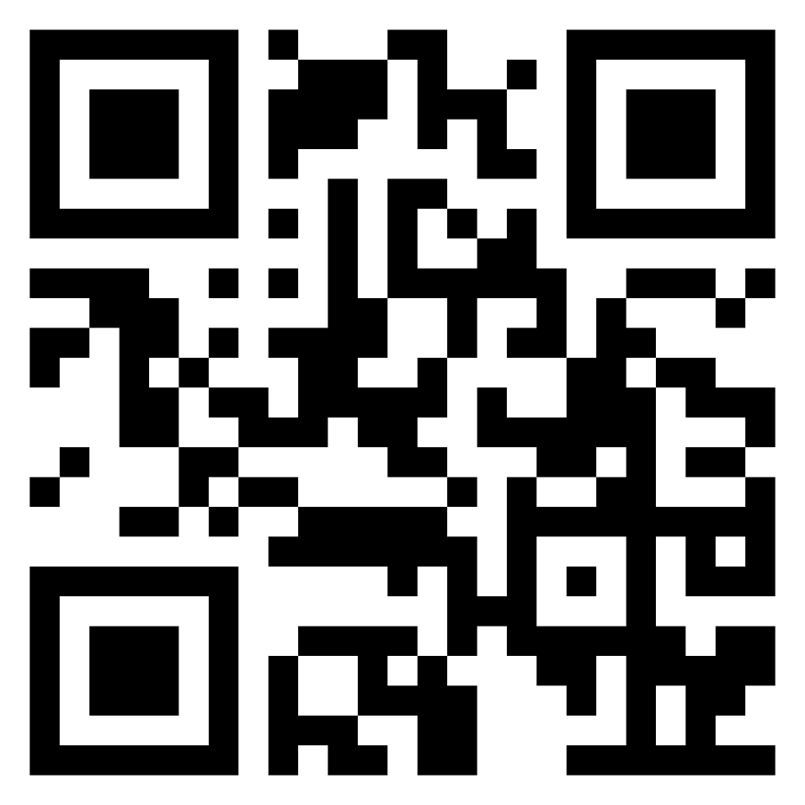

Discontinued Suit: Limited Supply, use the above QR code.
